3.0 Introduction

Skill and Chance was the central theme, however it had to be applied to the game of Noughts and Crosses. This was different from previous tasks because the goal was not to create a new game with the theme but implement the theme onto an already existing game.

3.1 Materials

* Paper to draw a four by four grid
* Pen or pencil to mark the X or O.
* One die that has X and O on each face
* A die with one to four on each face.

3.2 Rules

The rules for this game were:

* Two players are needed for this game.
* Before the start of the game players must choose to be either X or O.
* During each turn players must roll both dice.
* Players must first choose their row, then use the number on their numbered die to determine the column.
* If players cannot play during their turn they will have to miss that turn.
* The first player to fully fill a column or row wins the game.

3.4 Gameplay

The game worked similarly to a regular game of noughts and crosses. However rather than freely choosing where to place each shape, the game restricted movement by implementing the two dice which must be rolled at the start of every turn. These dice were what implemented the theme of chance into the game.

The die with the shapes on its faces determined which shape the player was allowed to play in that turn, sometimes forcing them to play a shape that belonged to their opponent. Next, was the number die, this piece was what decided the column that players were allowed to place their shape in. However players were allowed to pick the row where they would like to place their given shape.

From here on, players would then play the game in a similar fashion to regular noughts and crosses. However, in instances that a player couldn’t place their shape on a square, then they were forced to end their turn.

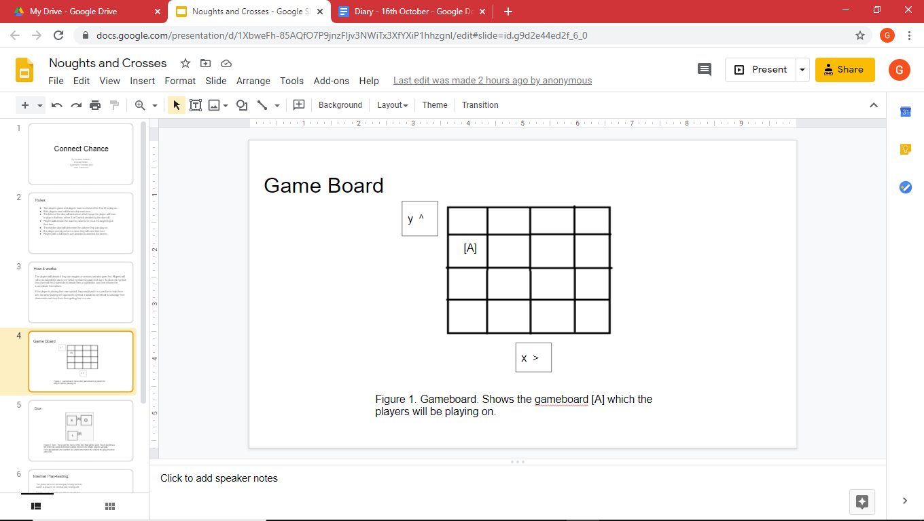

Figure 1. Gameboard. An example of how the gameboard [A] should be laid out. Players were only allowed to pick the row (x axis) while their column (y axis) were picked by the number die.

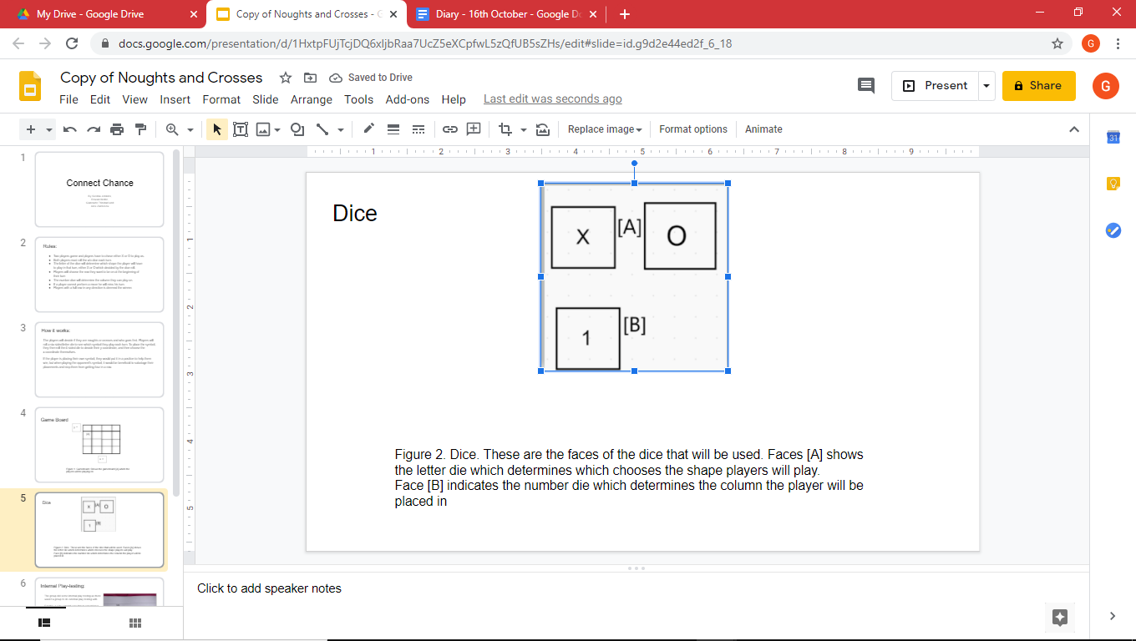

Figure 2. Dices. The top faces of the die [A] shows what the shape die would have on it, with every face either having the X or O. While the die face on the bottom [B] is what the numbers die would have and this die was what determined which column players could play on.

3.5 Test Play

No external play testing was provided, so internal play testing was done instead. The results of this test play was that the game was found to be winnable, which was relieving as there was a concern that the game was too difficult due to the heavy restrictions placed on the players’ movements.

3.6 Reflection

During development, there was a long discussion on how to tackle the task that took up most of the time. However once there was an agreement on how the game was going to work, every member was split up in order to tackle different tasks, such as the internal test play, creating the presentation and making the figures. By having the different roles, the final results came to good quality despite the small amount of time left for the exercise.

As this task was done online, personal performance mostly fell on communicating with teammates and problem solving. Overall communication was done well in both a personal standpoint and together with the team, because every member managed to comfortably present ideas. However, while dialogue between members was clear, problem solving and time management needs improving, because there was still no external play testing which meant no outside feedback was given.

Test Play members:

* Sienna Jenkins
* Rowan Noble